Ürün İsmi :  Product Name | 38 OZ KRAFT | Ürün Görseli / Product Image  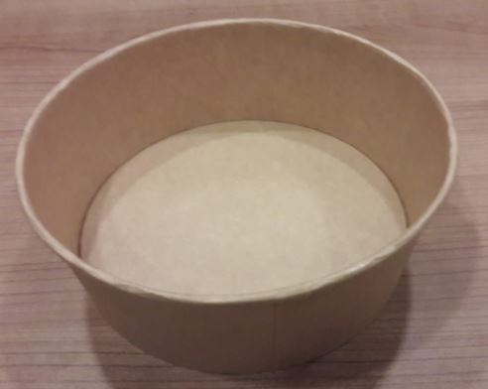
Ürün Kodu :  Product Code | CUPC 38OZ-0039
Fiziksel Özellikler / Physical Properties
Hammadde Bilgisi :  Raw Material | Kraft Paper | Hacim (cc) :  Brimful Volume (cc) | 1100
Ürün Ağırlığı (g) :  Product Weight(g) | 20 g ± %5 | Paketteki Ürün Miktarı:  Quantity In a Packet (pcs) | 45
Yükseklik (mm) :  Height (mm) | 66,5 | Kolideki Paket Miktarı:  Quantity of Packs In a Box (pcs) | 4
Ağız Çapı (mm) :  Top Diameter (mm) | 186 | Koli Ölçüleri :  Box Dimensions (WxLxH) (mm) | 385*385*485
Taban Çapı (mm) :  Bottom Diameter (mm) | 161 | Kolideki Ürün Miktar:  Total Quantity In a Box | 45*4
Depolama Süresi :  Storage Time |  | 3 yıl / 3 Years
Depolama Koşulları :  Storage Conditions |  | (0) - (+40) ºC kuru nemsiz ve tozsuz ortamda.  It should be stored at the dry environment ((0) - (+40) ºC), without moisture and dust.
Kullanım Şekli :  Usage |  | Gıda ambalajı için gıdaya direk veya dolaylı temas eder.  It is suitable for contacting kinds of salad directly or indirectly.
Allerjen Bildirimi :  Allergen Notification |  | Alerjen madde içermez. Alerjen maddelerle depolanmamalı.  It does not include any allergenic ingredients. ALLERGEN-FREE It should not be stored together with the allergen substances
Yönetmelikler ve Mevzuatlar :  Regulations and Legislations |  | Türk Gıda kodeksi gıda ile temas eden madde ve malzemeler yönetmeliğine  - REGULATION (EU) No 516/2014 OF THE EUROPEAN PARLIAMENT AND OF THE COUNCIL  of 16 April 2014  - COMMISSION REGULATION (EC) No 2023/2006  - REGULATION (EC) No 1935/2004 OF THE EUROPEAN PARLIAMENT AND OF THE COUNCIL  - COMMISSION REGULATION (EU) No 10/2011  - BRC-IOP Veriyon 5 standartlarına  uygunluğunu deklere ederiz.  Trendpack company declares that the Turkish Food Codex is in compliance with the regulations on materials and materials in contact with food. Moreover It complies with the following regulations:  - REGULATION (EU) No 516/2014 OF THE EUROPEAN PARLIAMENT AND OF THE COUNCIL  of 16 April 2014  - COMMISSION REGULATION (EC) No 2023/2006  - REGULATION (EC) No 1935/2004 OF THE EUROPEAN PARLIAMENT AND OF THE COUNCIL  - COMMISSION REGULATION (EU) No 10/2011  - BRC-IOP Version 5

